**TERMS AND CONDITIONS**

**EASTSIDE UNION SCHOOL DISTRICT**

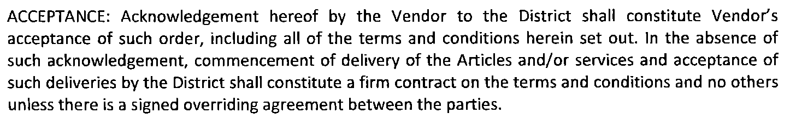



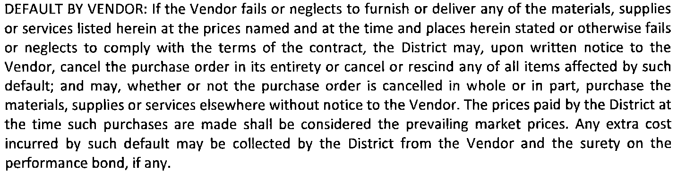

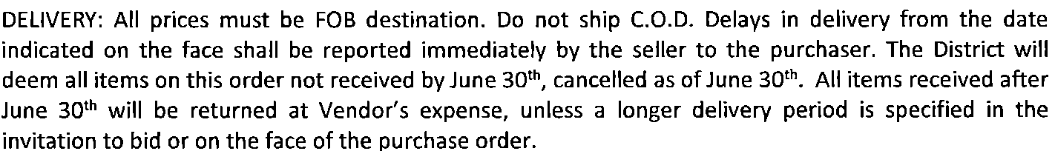



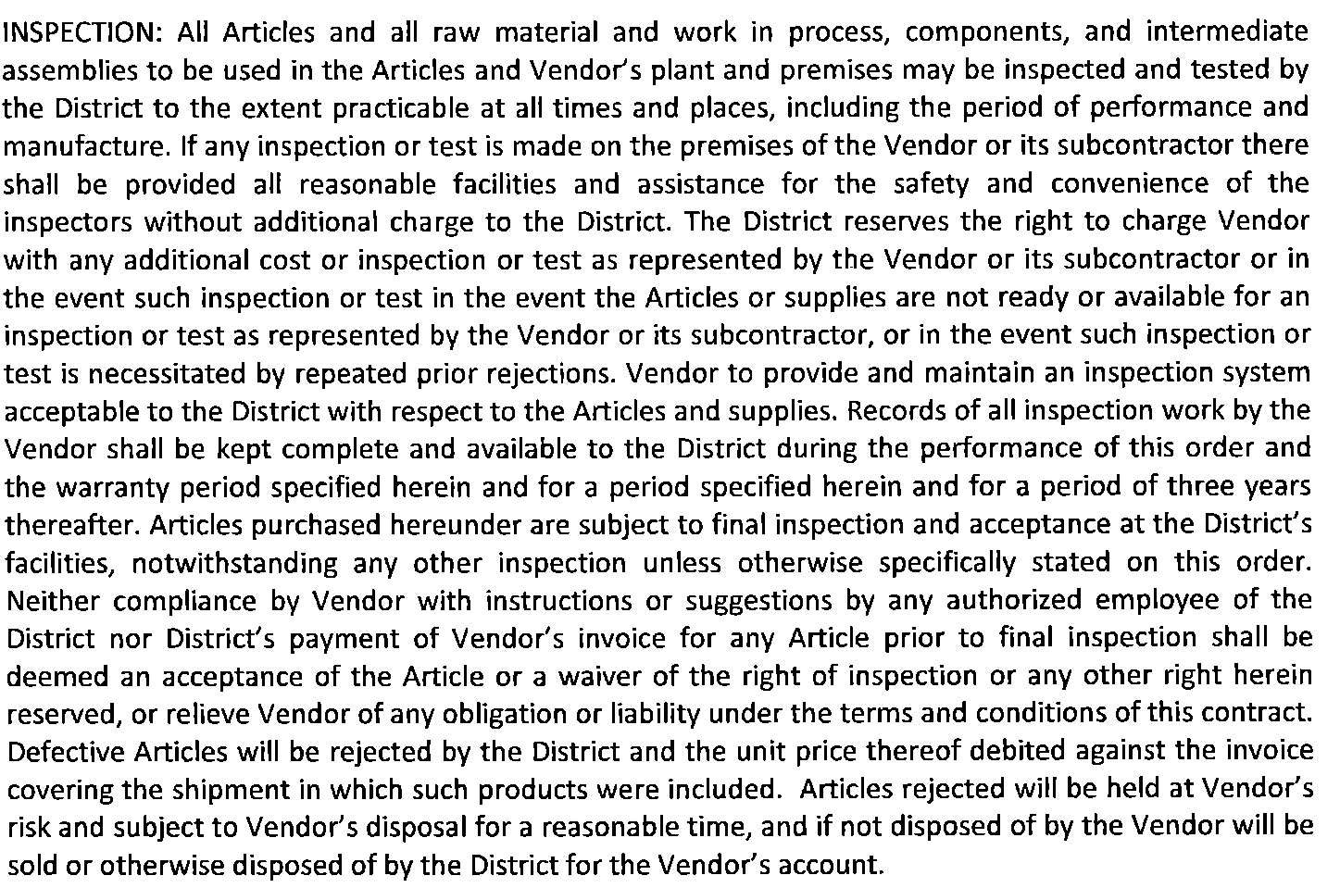

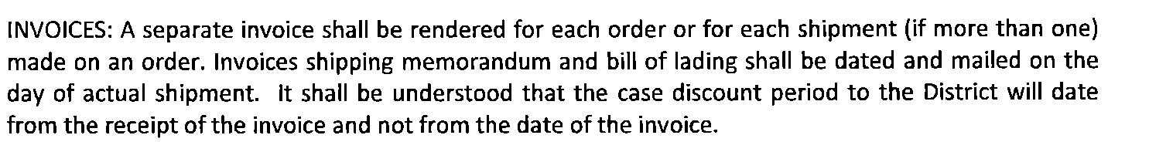

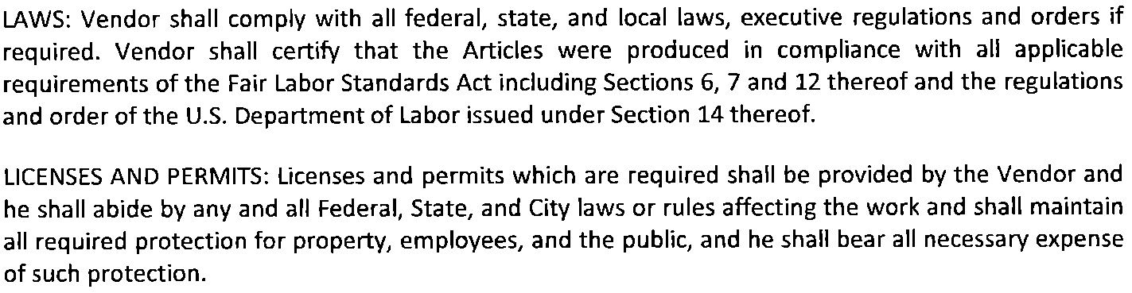



**NAME AND NATURE OF VENDOR’S LEGAL ENTITY: Should a change be contemplated in the name or nature of the Vendor’s legal entity, the Vendor shall first notify the Purchasing Department in writing in order that proper steps may be taken to have the change reflected on the purchase order.**

